Name : Ansari Ahmed Mohammed Asif
Experiment No. 08
Aim: To study and Implement Database as a Service on SQL databases Using AWS RDS.
Database as a Service (DBaaS) is a cloud computing model where database management is provided as a managed service. In this experiment, DBaaS is studied and implemented using Amazon Relational Database Service (AWS RDS).
1. Concept of Database as a Service (DBaaS)
Database as a Service (DBaaS) allows users to create, operate, and scale databases in the cloud without managing physical servers or database software manually. The cloud provider handles tasks such as:
- Hardware provisioning
- Database installation
- Patching and updates
- Backup and recovery
- Scaling and monitoring
Users only manage the database schema, queries, and application integration.
Benefits of DBaaS
- Reduced administrative overhead
- Automatic backup and patching
- High availability
- Scalability on demand
- Cost-effective pay-as-you-use model
- Some Popular DBaaS Providers
Provider | Service Name
Amazon Web Services | Amazon RDS, Amazon Aurora
Microsoft Azure | Azure SQL Database
Google Cloud | Cloud SQL
IBM | IBM Db2 on Cloud
Oracle Corporation | Oracle Autonomous Database

2. SQL and NoSQL Databases Supported by AWS

AWS supports both relational (SQL) and non-relational (NoSQL) databases.

SQL Databases (Relational)

Supported under Amazon RDS:
- MySQL
- PostgreSQL
- MariaDB
- Oracle
- Microsoft SQL Server
- Amazon Aurora

NoSQL Databases in AWS
- Amazon DynamoDB – Fully managed NoSQL database
- Amazon DocumentDB – Document database
- Amazon Keyspaces – Managed Apache Cassandra
- Amazon Neptune – Graph database

3. Difference Between RDS and Aurora
Feature | Amazon Relational Database Service | Amazon Aurora
Type | Managed relational DB service | High-performance relational DB engine
Compatibility | Supports multiple DB engines | Compatible with MySQL & PostgreSQL
Performance | Standard performance | Up to 5x faster than MySQL
Storage Scaling | Manual scaling | Automatic scaling up to 128 TB
Cost | Lower cost | Slightly higher cost
Use Case | General-purpose applications | High-performance enterprise workloads

Summary
- RDS is a managed database service supporting multiple engines.
- Aurora is a high-performance, AWS-optimized database engine under RDS.

4. Important AWS Terms in DBaaS

a) Storage Types

In AWS RDS, storage types determine database performance:
- General Purpose (SSD) – Balanced performance
- Provisioned IOPS (SSD) – High-performance workloads
- Magnetic Storage – Low-cost legacy option

b) Endpoint

An endpoint is the connection URL (DNS name) used by applications to connect to the RDS database instance. It contains:
- Hostname
- Port number
- Database identifier

Example format:
database-name.xxxxx.region.rds.amazonaws.com

c) Snapshot

A snapshot is a backup of the entire RDS database instance at a specific point in time.

Types:
- Automated snapshots
- Manual snapshots

Snapshots are stored in Amazon S3 and can be used for restoration.

d) Read Replica

A Read Replica is a copy of the primary database instance used to handle read-only traffic.

Purpose:
- Improves performance
- Reduces load on primary DB
- Used for reporting and analytics

e) Single-AZ and Multi-AZ Instances

Single-AZ Deployment
- Database runs in one Availability Zone
- Lower cost
- Suitable for development/testing

Multi-AZ Deployment
- Primary DB + standby replica in different Availability Zone
- Automatic failover
- High availability for production environments

Implementation Steps

Part 1: Database Creation and Connection
1. Create the RDS Database Instance Navigate to the AWS RDS Dashboard and create a new database. For this experiment, a MySQL Community engine (db-sarthak) running on a db.t4g.micro instance is provisioned.
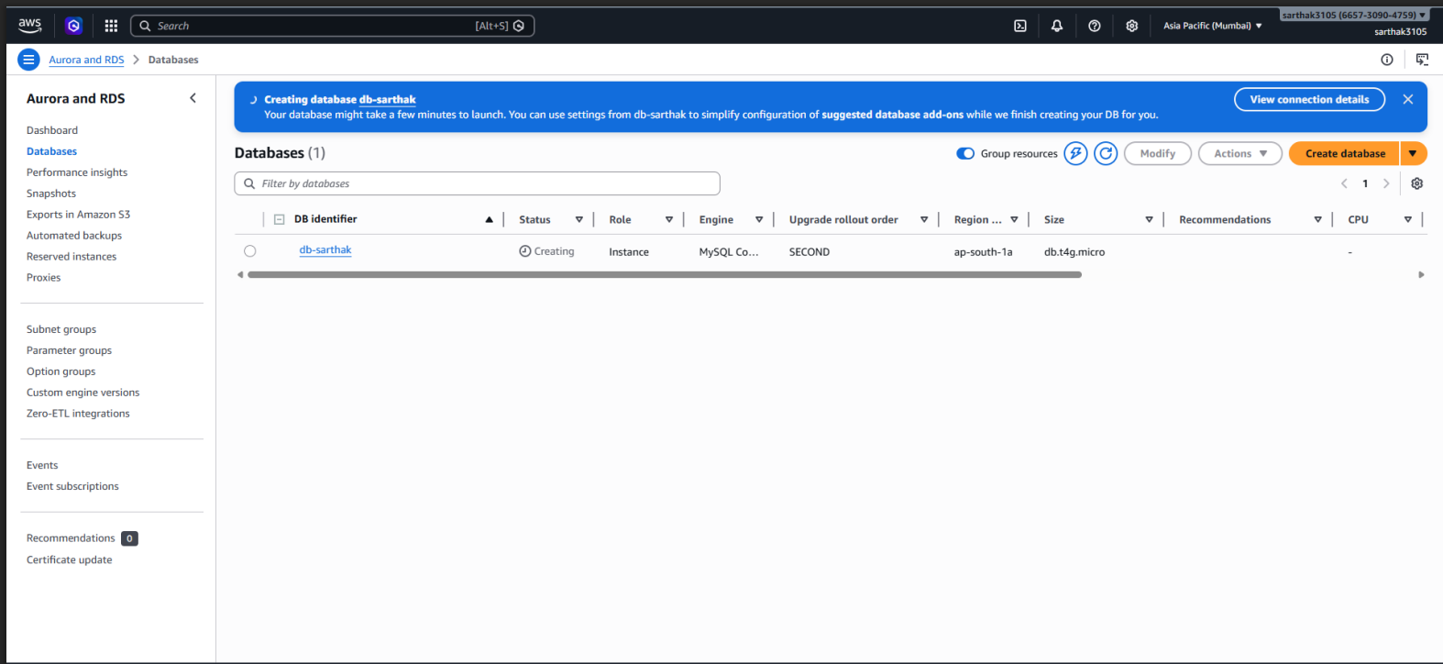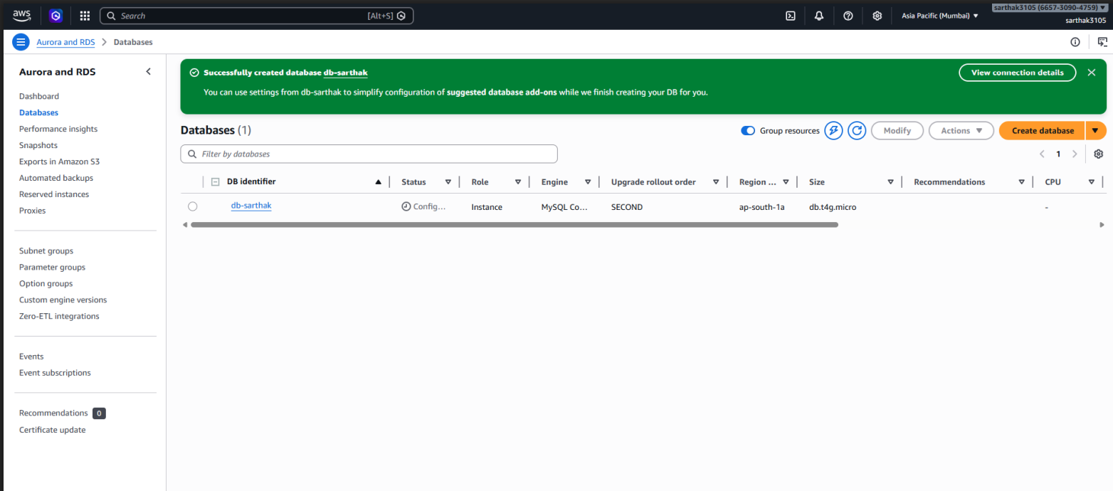
2. Retrieve Connectivity Details Once the database status is "Available", navigate to the "Connectivity & security" tab to copy the endpoint URL (e.g., db-sarthak.c9wwk8qoq24t.ap-south-1.rds.amazonaws.com) and port number (3306).
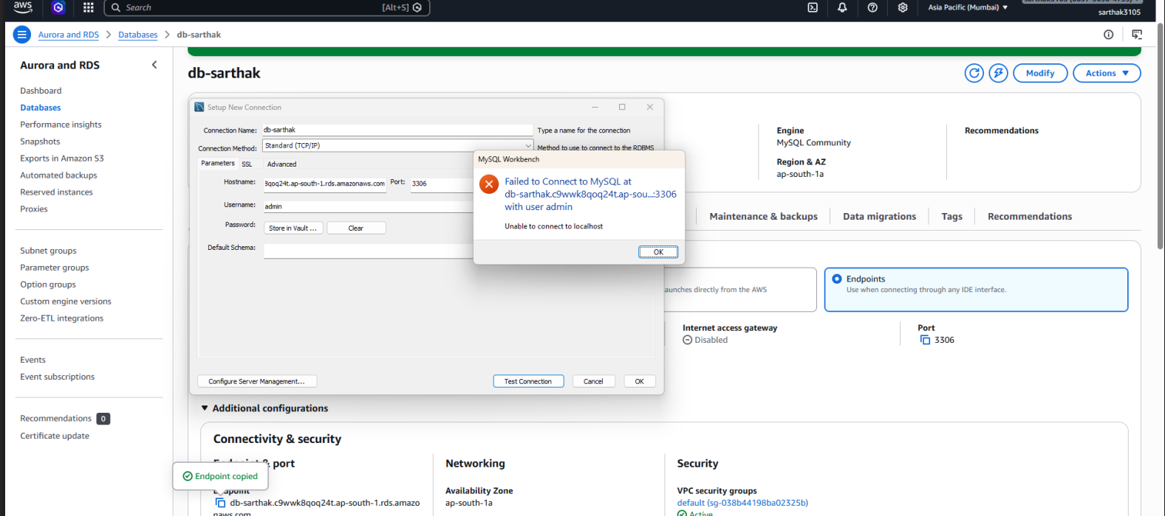
3. Establish Connection via MySQL Workbench Open MySQL Workbench, click "Setup New Connection," paste your AWS RDS endpoint into the "Hostname" field, and enter your master username (admin) and password. Click "Test Connection" to verify successful access.
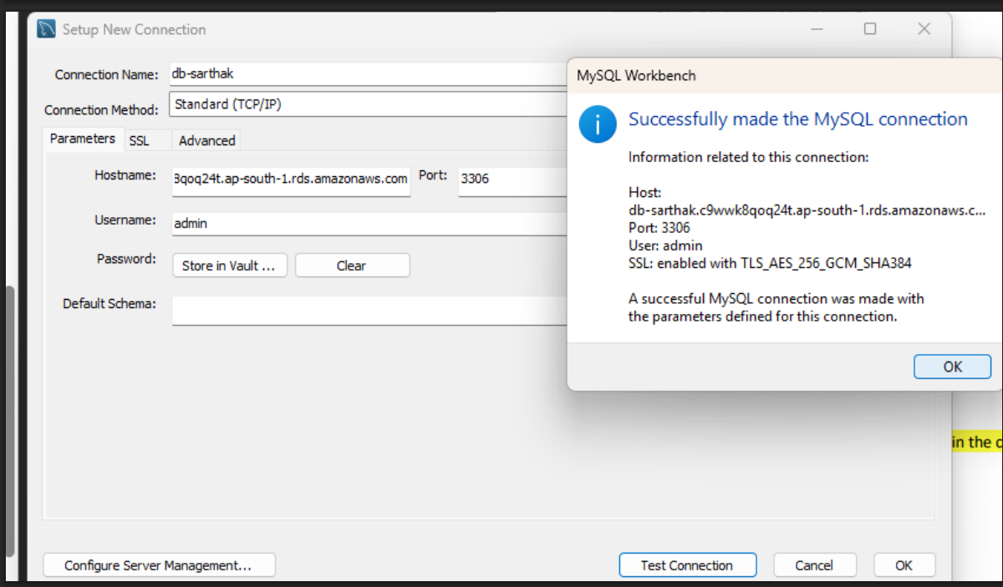

Part 2: Demonstrating CRUD Operations
4. CREATE: Inserting Data into the Database Write an INSERT INTO SQL query to populate your students table with initial records (e.g., Sarthak Agrawal, Rahul Sharma, Priya Mehta) and execute the query.
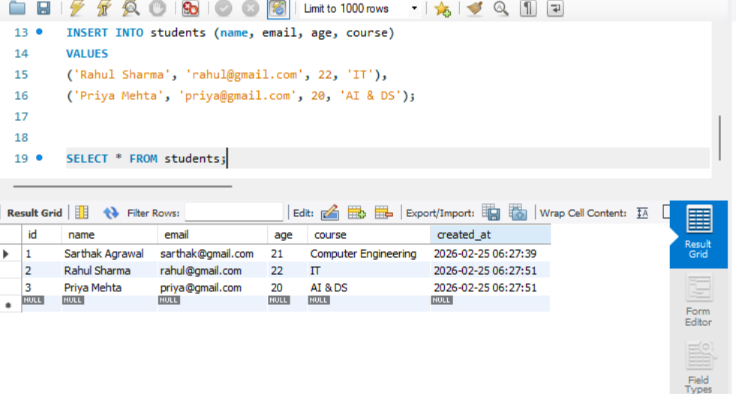
5. READ: Retrieving Data Use the SELECT statement to retrieve and view data. You can fetch all columns using SELECT * FROM students or fetch specific columns like SELECT name, course FROM students.
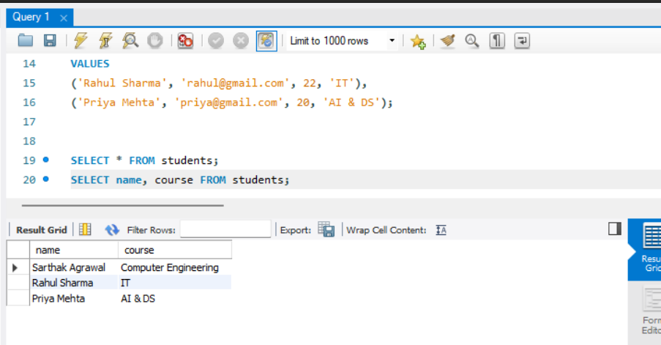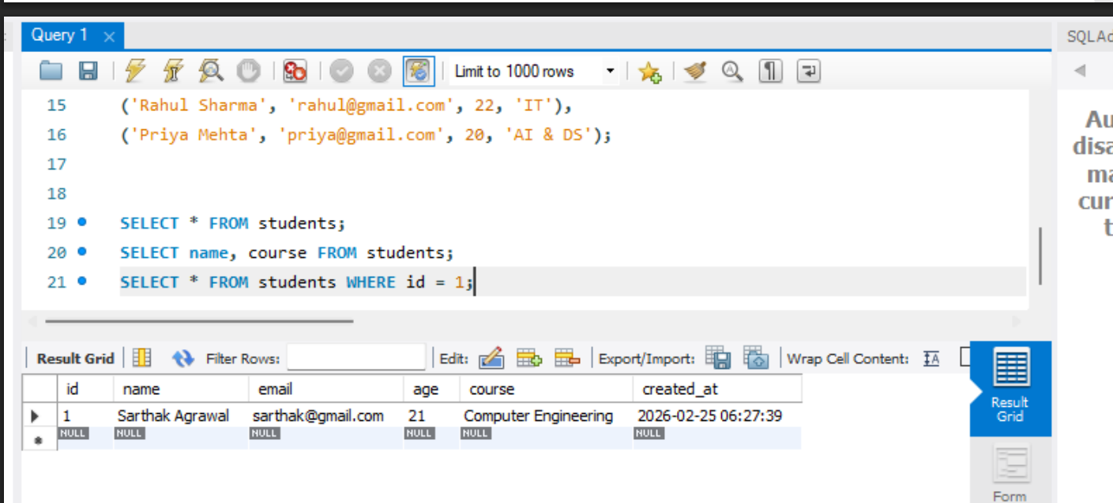
6. UPDATE: Modifying Existing Records Use the UPDATE command to change specific data fields. For example, update the course for ID 1 to 'Artificial Intelligence' and change the age and email for ID 2.
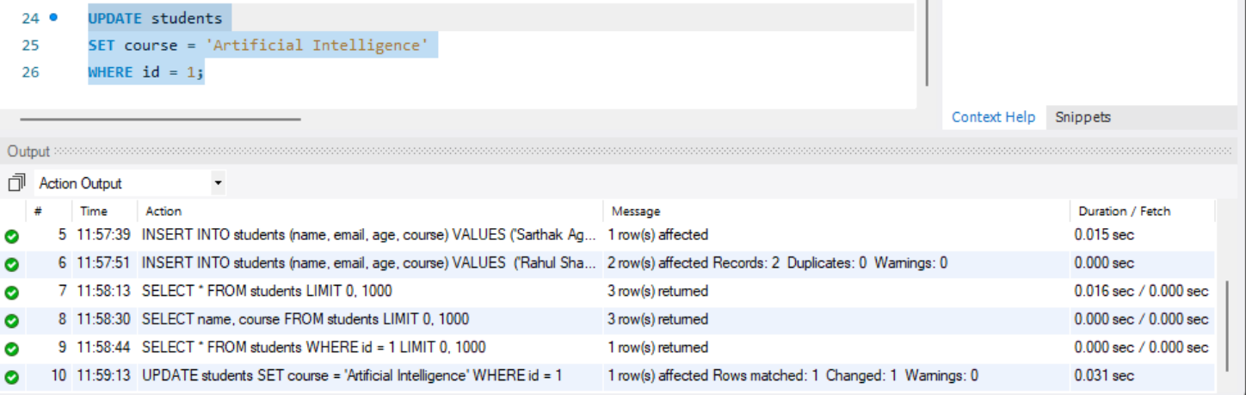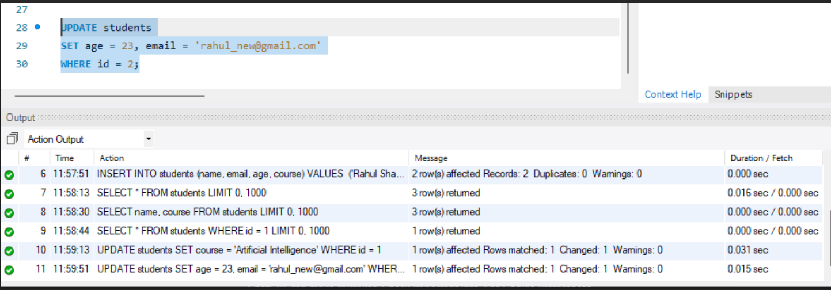
7. DELETE: Removing Records Execute a DELETE FROM query to remove a specific record from the table (e.g., removing the student with id = 3). Run a final SELECT * query to verify the updated table contents.
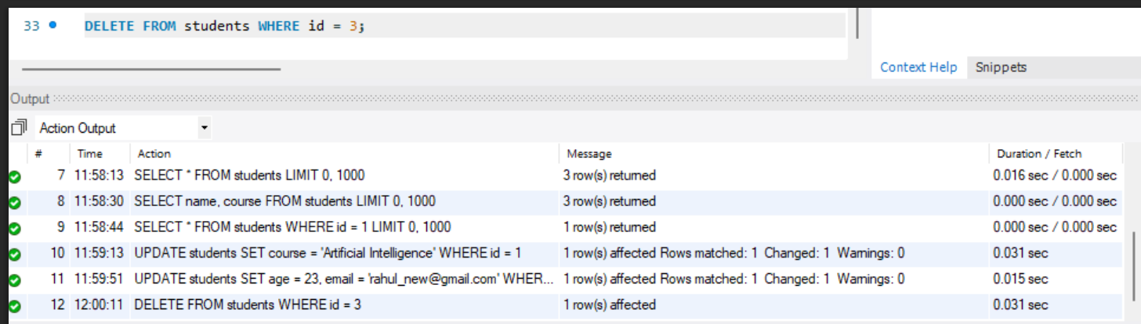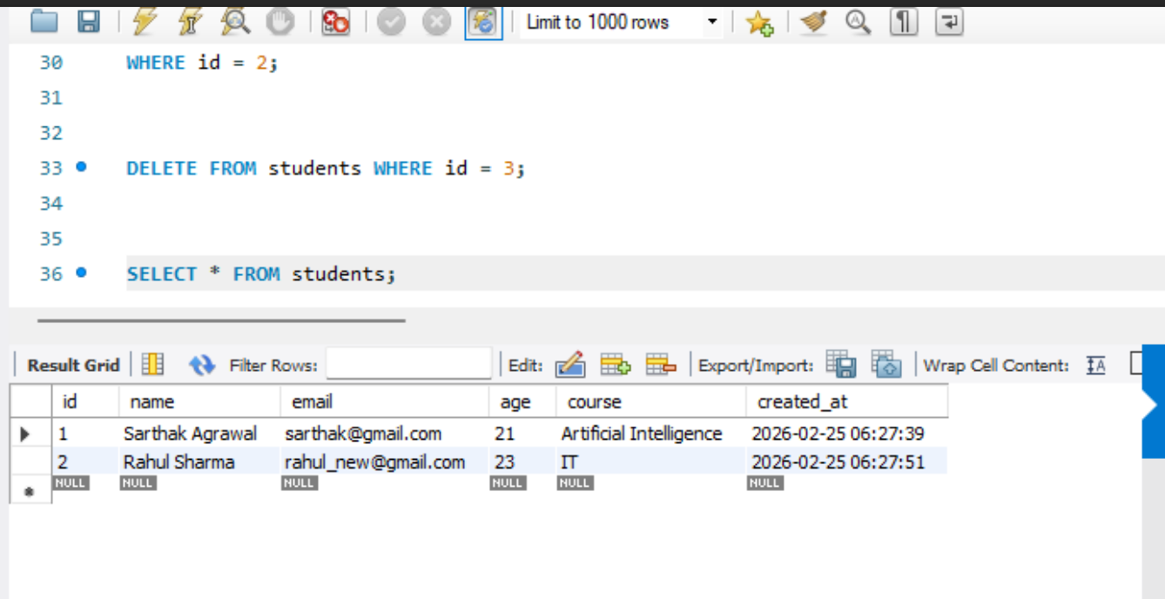

Part 3: Resource Cleanup
8. Initiate Database Deletion Return to the AWS RDS Console, select your db-sarthak instance, and choose "Delete" from the Actions menu. Uncheck the option to create a final snapshot and type delete me to confirm.
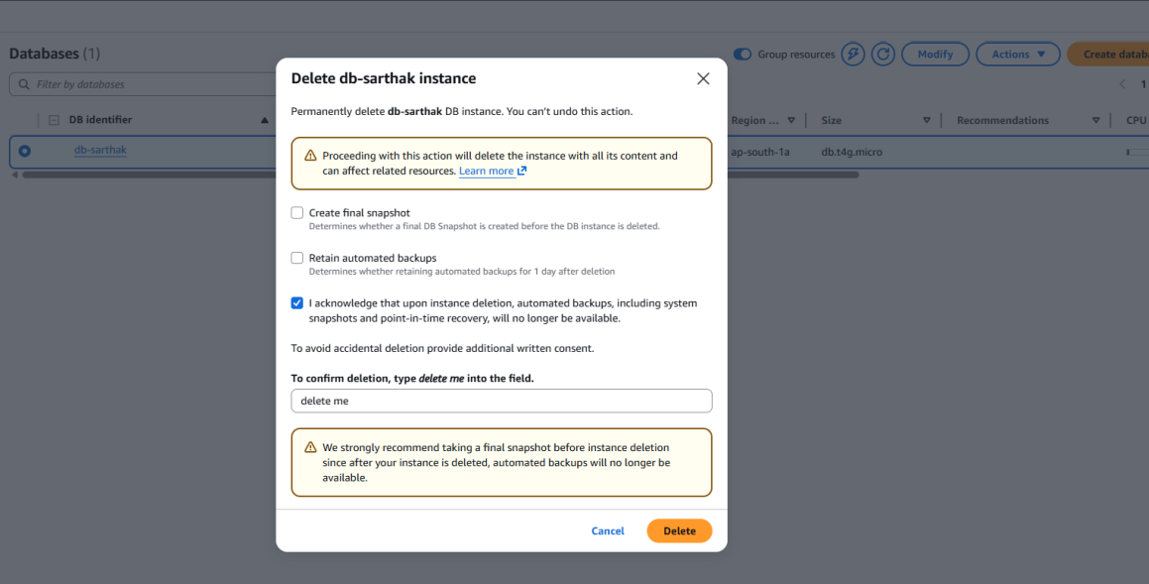
9. Confirm Deletion The database status will change to "Deleting." Wait a few moments until you receive the green banner stating "Successfully deleted DB instance db-sarthak."
